Dear Parents,

We will be using Type to Learn for your child’s keyboarding instruction. Type to Learn wraps keyboarding lessons into an intriguing world of adventure and information, with instructional modules and exciting typing activities and games to reinforce keyboarding skills. Type to Learn is in the cloud and allows students to practice from anywhere they have a current web browser and an internet connection.

To Launch the Type to Learn Adventure, please follow these easy steps:

- Go to www.typetolearn.com
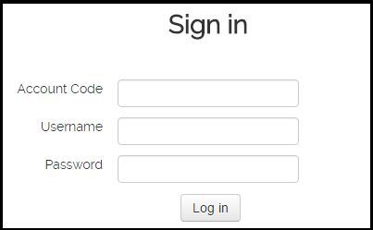
- Enter your account information
Account Code: _______________
Username: _______________
Password: _______________
- Select Launch Type to Learn
